Program 1: Generate a product description for a Smart Fitness Watch

Zero-shot Prompt
Prompt:
Write a product description for a Smart Fitness Watch.
Generated Output:
The Smart Fitness Watch is a sleek and stylish wearable designed to help you achieve your health and fitness goals. It features heart rate monitoring, sleep tracking, step counting, calorie tracking, and multiple sports modes. With water resistance, long battery life, and smartphone notifications, it is the perfect companion for an active lifestyle.

One-shot Prompt
Prompt:
Example: Product: Wireless Earbuds. Description: Experience crystal-clear sound with wireless earbuds featuring noise cancellation, long battery life, and a comfortable fit for everydayuse.
Now write a product description for a Smart Fitness Watch.
Generated Output:
Stay connected and healthy with the Smart Fitness Watch. Track your heart rate, sleep quality, daily activity, and workouts with precision. Its lightweight design, AMOLED display, water resistance, and up to 10 days of battery life make it ideal for fitness enthusiasts and busy professionals alike.

Few-shot Prompt
Prompt:
Example 1: Wireless Earbuds: Premium sound, noise cancellation, and all-day comfort.
Example 2: Smart Water Bottle: Tracks hydration, sends reminders, and keeps drinks cold for 24 hours.
Now write a product description for a Smart Fitness Watch.
Generated Output:
Achieve your fitness goals with the Smart Fitness Watch featuring real-time heart rate monitoring, blood oxygen tracking, sleep analysis, GPS support, and multiple workout modes. Its elegant design, water-resistant build, and long-lasting battery provide the perfect blend of style, health tracking, and everyday convenience.
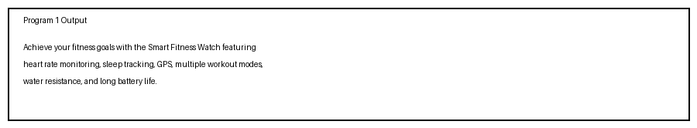

Program 2: Generate a 200-word blog on "Applications of Artificial Intelligence in Healthcare"

Zero-shot Prompt
Prompt:
Write a 200-word blog on the applications of Artificial Intelligence in Healthcare.
Generated Output:
Artificial Intelligence (AI) is transforming healthcare by improving diagnosis, treatment planning, and patient care. AI-powered systems can analyze medical images, detect diseases early, and assist doctors in making accurate decisions. Machine learning algorithms help predict patient outcomes and personalize treatments. AI chatbots provide 24/7 support, while robotic surgery enhances precision. Hospitals also use AI for scheduling, resource management, and reducing operational costs. As technology advances, AI will continue to improve healthcare quality and accessibility.

One-shot Prompt
Prompt:
Example: Write a 200-word blog on renewable energy with an introduction, benefits, challenges, and conclusion.
Now write a 200-word blog on the applications of Artificial Intelligence in Healthcare.

Generated Output:
Artificial Intelligence is revolutionizing healthcare by enhancing medical diagnosis, treatment planning, and patient monitoring. AI assists doctors in detecting diseases such as cancer and heart disorders through medical imaging and data analysis. Wearable devices use AI to monitor vital signs in real time. Virtual assistants improve patient engagement, and robotic systems support minimally invasive surgeries. Although data privacy and ethical concerns remain, AI has the potential to make healthcare more efficient, accurate, and accessible.

Few-shot Prompt
Prompt:
Example 1: Technology blog with introduction, examples, and conclusion.
Example 2: Education blog with benefits, challenges, and future impact.
Now write a 200-word blog on the applications of Artificial Intelligence in Healthcare.
Generated Output:
Artificial Intelligence has become a powerful tool in modern healthcare. From diagnosing diseases to managing hospital operations, AI improves both efficiency and accuracy. AI algorithms analyze medical records, laboratory reports, and imaging scans to support clinical decision-making. Predictive analytics helps identify high-risk patients, enabling early intervention. AI-powered wearables monitor health continuously, while virtual health assistants provide personalized support. Robotic surgery increases precision and reduces recovery time. AI also accelerates drug discovery and medical research. Despite concerns about data security, transparency, and bias, responsible AI implementation can significantly improve patient outcomes. In the future, AI will play a central role in preventive, personalized, and accessible healthcare worldwide.
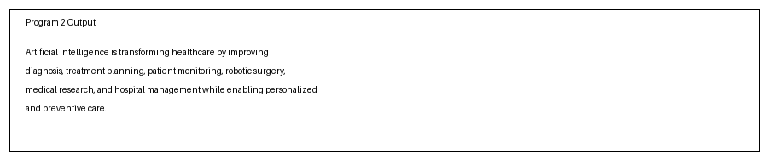

Program 3: Summarize an article into 50 words

Zero-shot Prompt
Prompt:
Summarize the following article in exactly 50 words.
Generated Output:
The article explains how AI improves healthcare through disease detection, medical imaging, predictive analytics, patient monitoring, and hospital management. It highlights increased efficiency, better treatment outcomes, and improved accessibility while acknowledging challenges related to privacy, ethics, and responsible implementation in modern healthcare systems worldwide.

One-shot Prompt
Prompt:
Example: Summarize a technology article in exactly 50 words, focusing on the main idea, key benefits, and conclusion.
Now summarize the following healthcare AI article in exactly 50 words.
Generated Output:
Artificial Intelligence is transforming healthcare by supporting diagnosis, treatment planning, patient monitoring, and hospital operations. AI enhances accuracy, efficiency, and accessibility through predictive analytics and automation. The article emphasizes AI’s growing importance while noting ethical, privacy, and implementation challenges that require careful management and regulation.

Few-shot Prompt
Prompt:
Example 1: Summarize in 50 words with only essential points.
Example 2: Summarize in 50 words with clear readability and logical flow.
Now summarize the healthcare AI article in exactly 50 words.
Generated Output:
AI is reshaping healthcare by improving diagnosis, treatment, patient monitoring, medical research, and hospital management. It enables faster decisions, personalized care, and better efficiency. The article concludes that AI offers significant healthcare benefits, but privacy, ethical considerations, and responsible implementation remain essential for sustainable adoption.
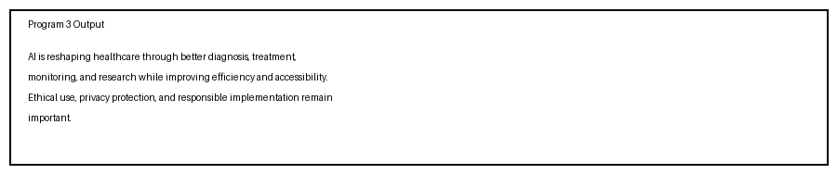

Program 4: Generate a professional email requesting leave due to illness

Zero-shot Prompt
Prompt:
Write a professional email requesting leave due to illness.
Generated Output:
Subject: Leave request due to illness
Dear Manager,
I am feeling unwell and unable to attend work today. I kindly request sick leave for one day. I will keep you updated about my recovery and resume work as soon as possible.
Thank you for your understanding.
Sincerely,
[Your Name]

One-shot Prompt
Prompt:
Example: Write a professional email with a clear subject, reason, leave duration, and polite closing.
Now write a leave email due to illness.
Generated Output:
Subject: Sick leave request
Dear Sir/Madam,
I am writing to inform you that I am suffering from a fever and have been advised to take rest. I request leave for two days, from 10 August 2026 to 11 August 2026. I will complete any pending work after my recovery.
Thank you for your consideration.
Kind regards,
[A.PRADEEP]

Few-shot Prompt
Prompt:
Example 1: Formal leave email with dates and medical reason.
Example 2: Polite leave email mentioning work handover and gratitude.
Now write a professional leave email due to illness.
Generated Output:
Subject: Request for sick leave
Dear Sir/Madam,
I am writing to request sick leave as I am currently experiencing a viral illness and my doctor has advised rest. I kindly request leave from 10 August 2026 to 12 August 2026. I have informed my teammate about urgent responsibilities and will remain reachable for critical matters if needed.
I apologize for any inconvenience and appreciate your understanding.
Sincerely,
A.Pradeep
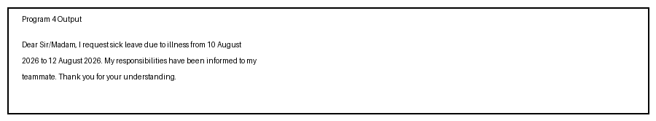
Program 5: Generate a promotional social media post for an AI Workshop

Zero-shot Prompt
Prompt:
Write a promotional social media post for an AI Workshop.
Generated Output:
Join our AI Workshop and discover the future of Artificial Intelligence! Learn machine learning, prompt engineering, and AI tools through interactive sessions and hands-on projects. Register today and enhance your career skills. Limited seats available.

One-shot Prompt
Prompt:
Example: Create a promotional post with a headline, key benefits, date, and call to action.
Now write a promotional social media post for an AI Workshop.
Generated Output:
Unlock the Power of AI!
Join our AI Workshop on 15 August 2026 and learn AI tools, machine learning basics, and prompt engineering from industry experts. Hands-on sessions, certificates, and networking opportunities included. Register now and secure your seat!

Few-shot Prompt
Prompt:
Example 1: Short engaging promotional post.
Example 2: Event promotion with benefits and urgency.
Now write a promotional social media post for an AI Workshop.
Generated Output:
Ready to Build with AI?
Join our AI Workshop 2026 and gain practical experience in generative AI, prompt engineering, automation, and real-world AI applications. Learn from experts, participate in live demos, and earn a certificate of completion. Seats are limited—register today! #AIWorkshop #ArtificialIntelligence #CareerGrowth
Conclusion
Few-shot prompting consistently produced the best results across all tasks. It generated outputs with better structure, higher accuracy, stronger readability, more persuasive language, and greater completeness than zero-shot and one-shot prompting.
